Field of diversity: | 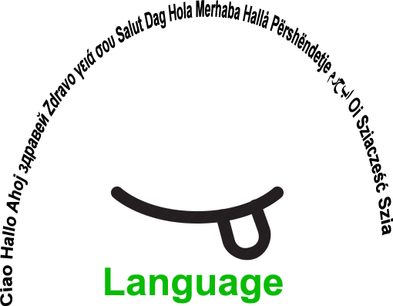 |  | L1 |  | Group size:  
Title | Classroom Mascot
Content | Understanding other students' ways of living, habits and customs |  |  |  |   Time: 5 minutes/ once a week, every week
Goals (Skills/Competences) | Express yourself in your native language or in a foreign language  Social competence
Material | Camera  (computer, projector)
Procedure: | - The teacher presents an object (garden gnome, cuddly toy, teddy bear...) that will be the mascot of the class  - The students of the class decide on a name for this mascot  - Every week one student at a time takes this mascot anywhere (s)he goes and takes photos of it  - After this week spent with the mascot, the student makes a power point presentation/video with the pictures (s)he took.  - (S)He then shows the class the pictures and comments on them.  - At the end of the school year, each student decides on the best photo (s)he took in order to exhibit during the school open-day.
Modifications
Comments
Success    factors |  | Pitfalls  
The activity is flexible and depends on the local context. Feel free to adapt!
©
UDEL 21

