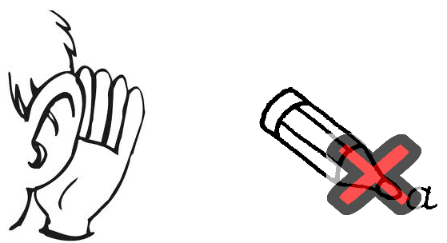 | 
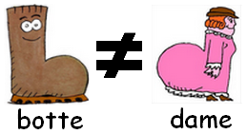 | 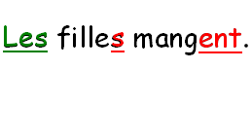
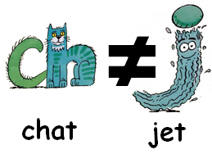 | 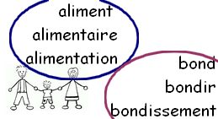
 | 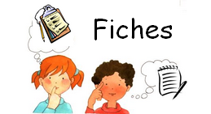
Annex to BE_FR_04_When I reread I pay attention to…

« When I reread I pay attention to… »
(according to French language)

- capital letters and dots

- verb and subject agreement (using colours to identify both of them)
- visual differences

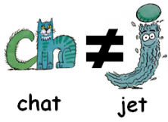
- differences between two similar sounds

- to help myself with words belonging to the same « group » to remember the last letter
- to consult my « remind card »

- words that I have to know by heart (f.i. words that don’t have a plural form – people)

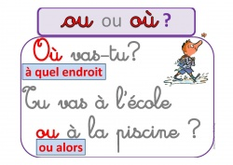 | 