Field of diversity: | 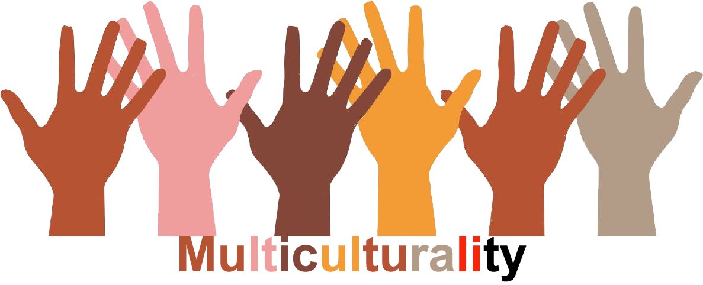 |  | L1 |  |   Group size:
Title | My way to here
Content | Sharing-explaining each pupil geographic travel from the native region to the school to show that everyone is rich of one’s history, experiences |  |  |  |   Time: one lesson
Goals (Skills/Competences) | To encourage openness to the others and communication between all the members of the group  To share orally everyone’s route with the others and understand the diverse backgrounds  To be able to locate everyone’s native region on a map + the countries or regions crossed on the way
Material | - Map of the world  - Coloured pins  - Wool thread  - Atlas (optional)
Procedure: | This activity has to be led at the beginning of the schoolyear to show that everyone is rich of one’s history, experiences  - Pupils stand around a World Map  - The school is localised by another pin  - One at a time, pupils tell their native region/country and put a pin on the right spot + other living places where they stayed  - They link their own pin to the school one with the wool thread to symbolize their travel  - Oral exchange on everyone’s story (native region/country – landscape, climate, smells, habits and customs…), travel, memories…  - Similarities, differences, common background…  - The map will stay in the class to figure the richness of the class diversity during the whole school year
Modifications
Comments
Success    factors | Respect and goodwill  Prepare your group positively to this exchange | Pitfalls   |  | This activity can be sensible to some members of the group. Don’t force anyone…
The activity is flexible and depends on the local context. Feel free to adapt!
©
UDEL 21

