Field of diversity: | 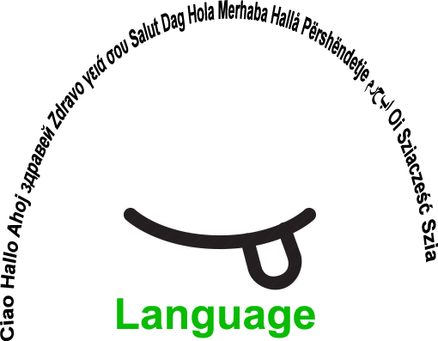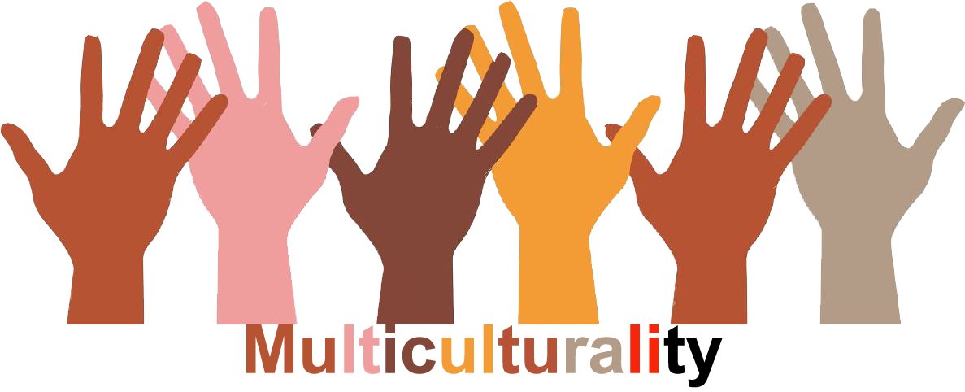 |  | L1 |  |   Group size:
Title | To introduce oneself with the help of a Mind-Map in a multi-cultural context
Content | The pupils introduce themselves with the help of a Mind-Map |  |  |  |   Time: 3-4 lesson periods
Goals (Skills/Competences) | To know each other and establish a collaborative learning community  The pupils’ self-confidence in using teaching language will increase  Sub-competences  - To make a visual support  - To prepare an oral presentation  - To speak about oneself (identity, origins, background, country, dreams…)
Material | - A blank Mind-Map that will be used as a model  - Blank A3 sheets  - Felt tip pens, coloured pencils  - Illustrations from magazines, pictures, visuals  - Pairs of scissors  - Glue
Procedure: | This activity has to be led at the beginning of the schoolyear, after the presentations.  - The teacher introduces himself with the support of a Mind-Map  - Then he asks the pupils to explain what he has just been doing and what he was talking about. The aim is to identify the sub-categories used in the description (my identity, my country, my tastes/hobbies, my family, my dreams). All the necessary/useful vocabulary has to be seen during the previous course. This activity is the final task  - The pupils must create their own Mind-Map et personalize it with pictures, drawings, photographs… the aim is to have a visual support without any sentence  - The pupils prepare their presentation in pairs: every pupil introduces himself to another one who will give him a feedback to improve his presentation  - The pupils present themselves to the class.
Modifications
Comments
Success    factors | The pupils can bring their favourite music, a dish from their country…  This activity can also be done via a software helping to create a Mind-Map  In order to create a participative atmosphere of all the pupils, give them an observation grid and ask their positive and friendly feedback at the end | Pitfalls   |  | Don’t address too emotional themes concerning their family (deaths, conflicts, divorce or separation…) Don’t force them to discuss about these topics.
The activity is flexible and depends on the local context. Feel free to adapt!
©
UDEL 21

