Field of diversity: | 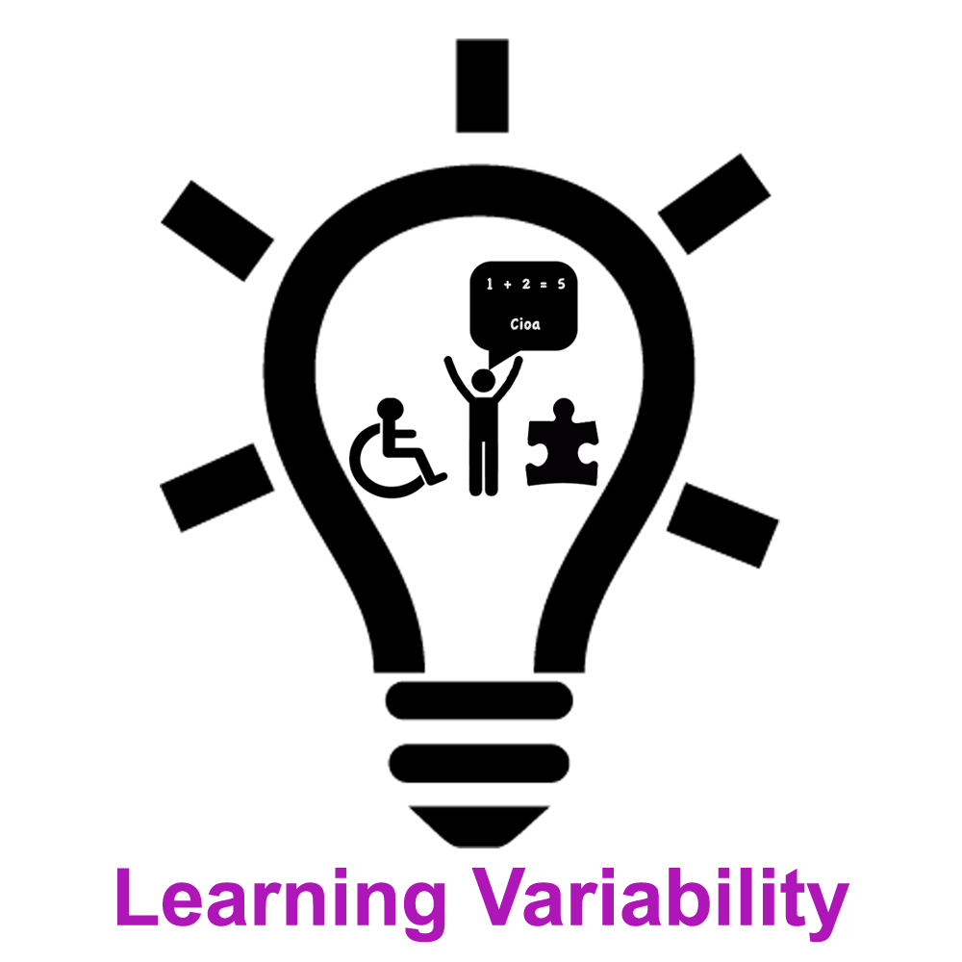 |  |  |  | Group size:  
Title | Resume a text
Content | Be able to resume a text helped by a mind map established by the teacher (cf enclosed card) |  |  |  |   Time: variable
Goals (Skills/Competences) | Be able to resume a text pointing the principal elements  Improve the comprehension of the text  Prepare the memorisation
Material | The mind map established by the teacher (cf enclosed card), dictionnary, paper, color pens, slat...  Text to resume
Procedure: | - Prepare the material  - Do an active reading of the texte (for example : underline the verbs, encircle the subjects…)  - Read again pointing out the differents ideas in the text  - Structure the ideas in paragraphs  - Work on the formatting of the sentences  - Use linking words to structure the paragraphs  Use whenever you want the methodological mind map to be sure that you have realized all the steps
Modifications
Comments
Success    factors |  | Pitfalls  
The activity is flexible and depends on the local context. Feel free to adapt!
©
UDEL 21

