Field of diversity: | 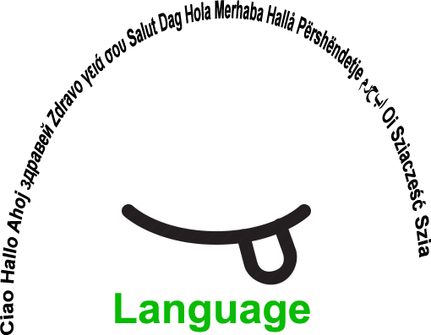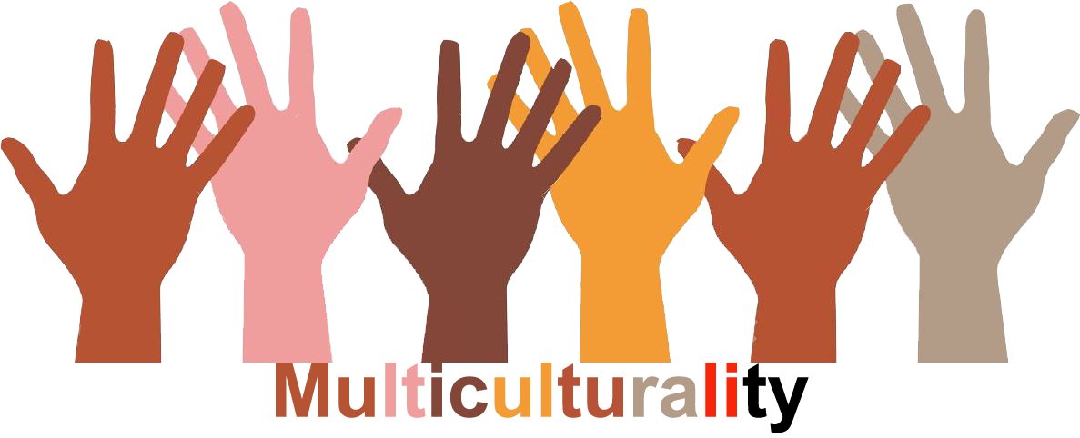 |  | L1 |  | Group size:  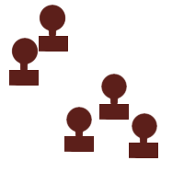
Title | Oral exchange between schools in Europe
Content | Speaking in a foreign language with a class from another European country. Promoting and setting up linguistic exchanges between schools. |  |  |  |   Time:
Goals (Skills/Competences) | Getting the opportunity to speak in a foreign language. Realizing that mistakes are allowed.
Material | Via Skype
Procedure: | - the teacher has already found a class in a school located in another European country, thanks to e-Twinning, and determined which language will be used for the exchanges  - the students in both schools present themselves (short videos, mails) so that pairs can be formed  - the students watch the videos/read the mails and choose their twin  - dates are determined by the teachers, on which the students will exchange on different subjects. Examples : my country and its traditions, my town/village, my school, a typical schoolday, my courses, my family, my hobbies, my tastes,... The appointments do not necessarily take place during the lessons : they can take place at lunchtime or at home.  Possible variation: this activity can be used for any course to exploit the linguistic diversity. For example: if you have a young Syrian, find an other school where you also have young Syrian and ask them to prepare a presentation (for it, they can use their own language). Then they present it in the local language to their respective class.  +e-Twinning
Modifications
Comments
Success    factors | The students should be the same age. | Pitfalls  
The activity is flexible and depends on the local context. Feel free to adapt!
©
UDEL 21

