1.  I’m ready to receive the information and I’m planning to do something with it.   | 2.  I take the information and put it in my head.    I watch in order to …  I listen in order to …  I touch in order to …
3.  I think about the information I got.  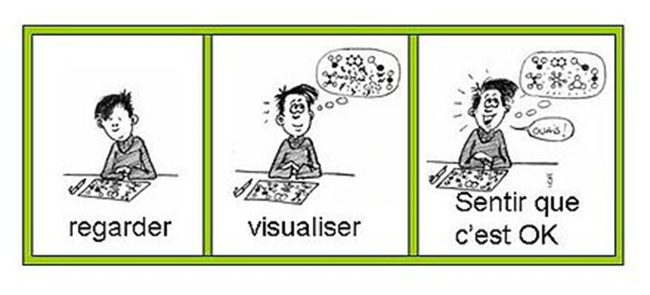 | 4.  I check if what I have in my head is what I wanted to get.  INGT/INDJ © D. Migeot

1.  I’m ready to receive the information and  in project to do something with it. | 2.  I take to put in my hat  I see for …  I for …  I for …
3.  I in my | 4.  I if wat I have in my is well what’ s I want  INGT/INDJ © D. Migeot

