Field of diversity: | 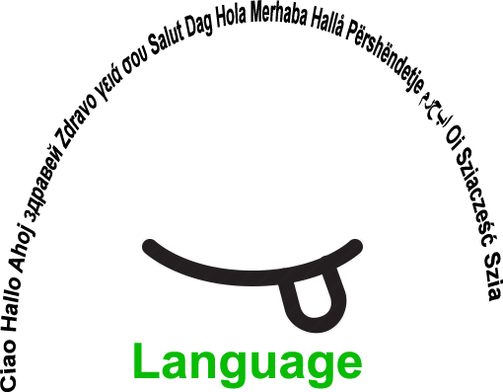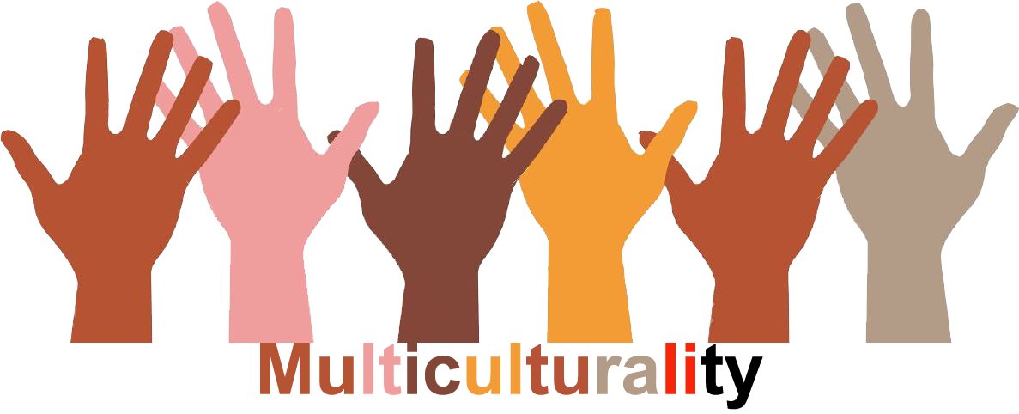 |  | L1 |  | Group size:  
Title | Fund raising for a good cause
Content | Involving students and parents to help students in need |  |  |  |   Time: cca 4 times a year
Goals (Skills/Competences) | To make students and parents aware of the necessity of helping people who are in need  To learn about empathy
Material | Water taps, old paper, coloured paper, glue, scissors,…  Material for creating greeting cards and small presents
Procedure: | Procedure  - At the beginning of every school year students are encouraged to collect old paper, plastic bottle taps 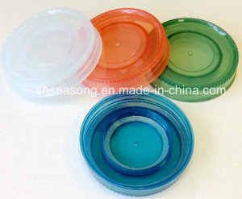 and various other materials. With the money collected by selling the products, school helps the students in need, e.g. by collecting water taps money is raised for a disabled ex-student, who has been paralysed since the accident he had two years ago. He needs a special wheelchair.  -During art and technology classes greeting cards and small presents are created. They are sold at the school bazaar in December.  The money earned at the bazaar sale goes to the school fund and is used to help some less privileged students attend activities like School in the nature, skiing, swimming ,.. that otherwise they could never afford.  + links
Modifications
Comments
Success    factors | Visitors willing to buy students' products.  Willingness to contribute in any way the visitors, parents and students want.  Support of the Municipality | Pitfalls   |  | /
The activity is flexible and depends on the local context. Feel free to adapt!
©
UDEL 21

