Field of diversity: | 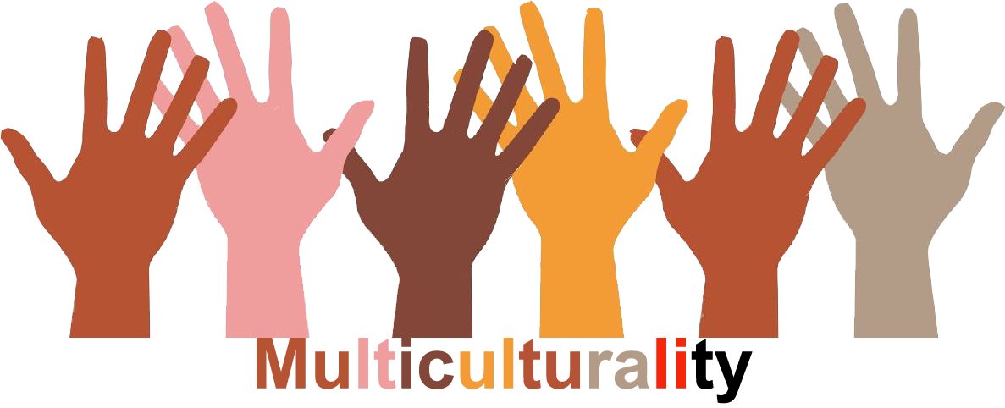 |  |  |  | Group size:  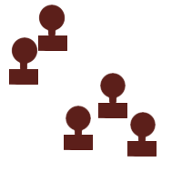
Title | The philosophical circle
Content | A philosopical circle dialogue around a specific actual theme that is very present in the context of the school/schools.  Source: Thomaswebsite KULeuven: www.dialoogschool.be (Dutch) ; Leen Dillen (pedagogical advisor IDE Katholiek Onderwijs Vlaanderen) |  |  |  |   Time: ½ hour
Goals (Skills/Competences) | Students practice having a dialogue and learn how to re-contextualise. They learn to expand and deepen their thinking and beliefs by taking the perspective of the other who has a different opinion and are invited to look beyond what others sponaneously say and do.
Material | Chairs in a circle and material to put on an empty chair. This material will be used during the dialogue.
Procedure: | - The teacher or a student brings in an actual theme in the circle, e.g. a newspaper article that caused a lot of students to react. Example: a refugee family that has been send back to their home-country.  - The students can ask questions.  - Different students can start the dialogue with input.  - The teacher invite students to come and sit on the empty chair in the middle where a book is placed: a Bible, a Koran, etc.  - The teachers reads a part from the book (this part will be used to confront the students with themselves and their opinions, beliefs)  More information and background on the Thomaswebsite KULeuven: www.dialoogschool.be (Dutch)
Modifications
Comments
Success    factors |  | Pitfalls  
The activity is flexible and depends on the local context. Feel free to adapt!
©
UDEL 21

