Field of diversity: | 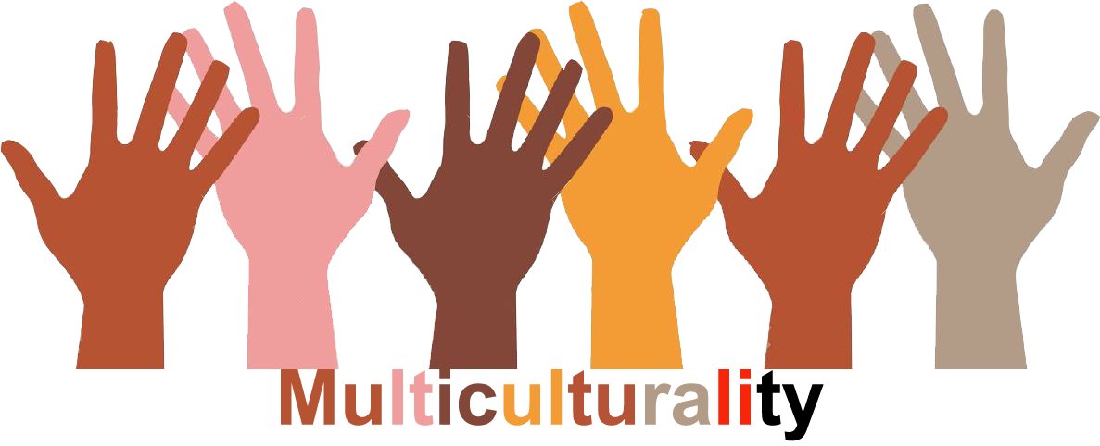 |  |  |  | Group size:  
Title | The children's council
Content | The children's council in a school is organised in a school. The council is composed of a number of chosen pupils (2 per classroom).  Sara Schouppe, primary school De Boomgaard and De Knipoog, Liederkerke. |  |  |  |   Time: 4X per year / more if necessary
Goals | - The pupils are stimulated to think about school matters and to invest in the school. This way they can learn democratic values.  - They learn to think independently and they learn how to come up for their rights. They learn how to express themselves.  - The pupils are the core of the school. It is important to know what is going on, to listen and as a consequence to work together.  - In addition to the ideas from the teachers, pupils often have a fresh and original perspective.  - Pupils come to realize, while being in a children’s council, that they can make a difference in their environment.  - The pupils experience how to have meetings. They talk and think together and they learn how to filter unimportant information, how to mediate, how to lead, how to make notes, how to work together and how to share responsibilities.
Material | A bulletin board, paper for the slogan.
Procedure: | - During the children’s council the pupils (2 from each class-room) can express their opinions and ideas and choose what is important to work on at school.  - The proposals are forwarded to the principal and the teacher’s team, so this way the proposals can become an agenda-item for their own team meeting.  - The council can also organize activities for charity or other initiatives, such as games for the playground.  - The council can come with solutions to recent topics, such as bullying and they can reflect together on school-rules.  - On the bulletin board all pupils can find the pictures of the members of the council, so everybody can recognize them easily. The slogan is also placed on the board. Underneath the board there is a box, where all pupils can put topics they want the council to address.  - Diversity-items and issues can be an agenda. On the long term, the council can work preventive towards possible conflicts about culture, religion, gender, and so on.  Other possibilities: a children’s council within the community: 2 representatives from each school come together to talk about “big” and “small” children’s affairs.  The following slogan should be visible throughout the school: “the children’s council helps everybody, so you are never alone”.
Modifications
Comments
Success    factors | - The council can only consist of pupils from a certain age.  - All items are discussed.  - Everybody has the chance to talk and everybody listens to each other.  - Solutions are realistic and achievable.  - Everybody at school is respected. Nobody talks about the members of the council. | Pitfalls  
The activity is flexible and depends on the local context. Feel free to adapt!
©
UDEL 21

