Field of diversity: | 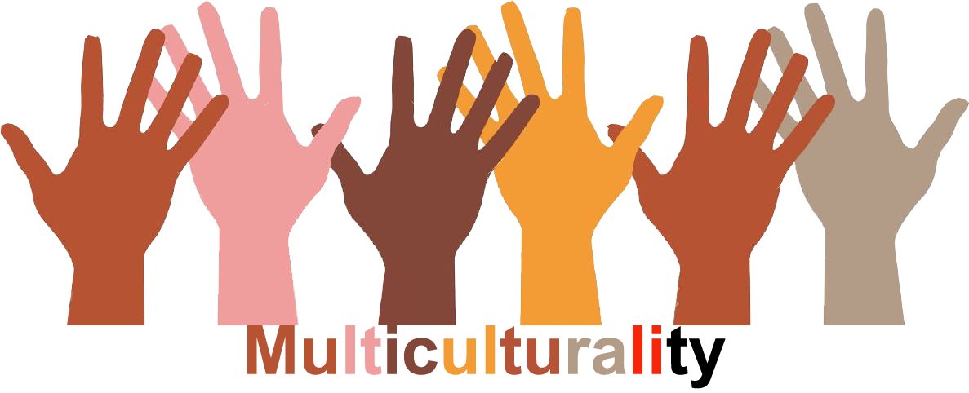 |  |  |  | Group size:  
Title | A project to build on understanding about other cultures and what it means to leave your country.
Content | The activity is part of a project about refugees. The activity is about taking the perspective of a refugee. Source: Netley Primary School, London. |  |  |  | 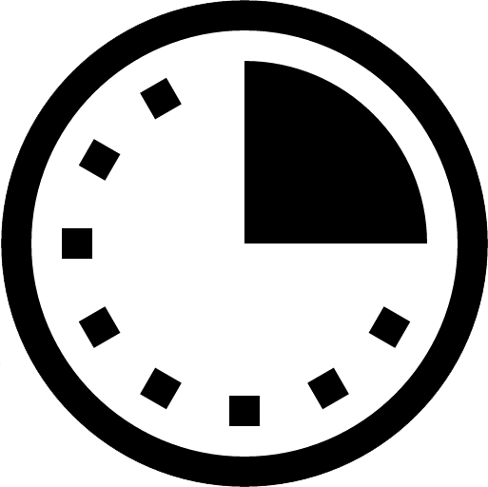  Time: 2 lessons
Goals (Skills/Competences) | Pupils learn perspective-taking skills.
Material | Drawing material, scissors, glue
Procedure: | - Pupils in all classes make big posters to illustrate groups of refugees who come to Europe, they decide themselves how to work: in groups, alone, … and how they make the posters: with pictures, drawings, …. This activity can be included in project work  - The pupils design a smart-phone and cut it out; they all make their own smart-phone but they can work together in pairs, in groups or alone.  - The pupils write a text-message in the smart-phone (or they can make a drawing). This is a message they want to send to their friends and/or family that stayed behind: it can be about the trip, the new country, ….  - Group discussion after presentation of each smart-phone  - The posters and smartphones are presented in the hall, outside of each class. Pupils can look at all the posters and can have conversations about it in class
Modifications
Comments
Success    factors | This activity cannot be a one-time activity. The awareness raising will only be effective after continuous returns to the posters and smartphone with dialogue-opportunities. | Pitfalls  
The activity is flexible and depends on the local context. Feel free to adapt!
©
UDEL 21

