Field of diversity: | 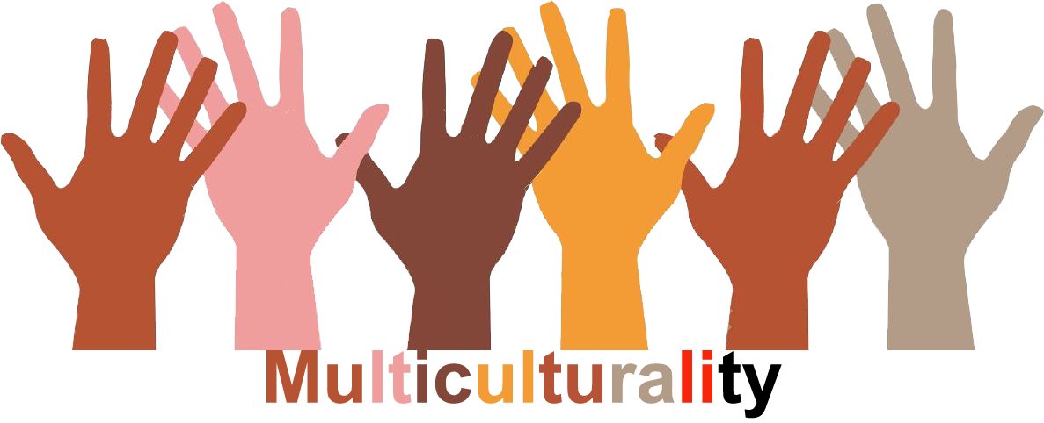 |  |  |  | Group size:  
Title | Meaningful leisure-activities for children
Content | - Creative workshops  - Multisport workshops  GOK-project Wonderwijs Brugge, Koen Depestel, Astrid Lenoir, Jan Legein, Peter Bracaval. Initiative, sponsored by Lions Oostkamp. |  |  |  |   Time: 10 sessions after school
Goals | - Collaboration between schools and sectors who work on a broad learning and living environment in order to give maximum chances for development for all children and youngsters.  - A bridge between these organizations and the parents and children.  - Stimulation of all children to do meaningful activities in their free time and to develop their talents.  - Creation of a broad learning and living environment in the free time of all children through external organizations.  - Participation of all children to existing external organizations through stimulation and support.
Material | - For the creative workshops: all kinds of material for using different techniques.  - For the multisport workshops: all kinds of sports-material
Procedure: | - Twice a year, children can register for one of both workshops (10 sessions)  - Parents pay for a small contribution. The rest comes from another source (e.g. sponsoring)  - The parents of children from disadvantaged families are personally invited just before the opening of the registration.  - The sessions start in October and February.  - At the end of each series of sessions parents, teachers, sponsors and the press are invited to expositions of the work of the children. workshops  Link: ‘De Sprookjestuin from Stefanie Van Maldegem’ (http://www.desprookjestuin.be/ ).  More information: see narrative “Meaningful leasure-activities for children”.
Modifications
Comments
Success    factors |  | Pitfalls  
The activity is flexible and depends on the local context. Feel free to adapt!
©
UDEL 21

