Field of diversity: |  |  |  |  | Group size:  
Title | Equality of gender in politics and other organisations in our world of today.
Content | This is an awareness raising activity to draw students' attention on gender issues in our world with the focus on (official) organisations. This activity is inspired by Netley Primary School, London |  |  |  |   Time: 2 hours
Goals (Skills/Competences) | Students are aware of gender issues in the world . Students become aware of unequal (political) participation chances for women, more specific in organizations around the world and more specifically near by (in our own environment)
Material | All kind of material to make posters: magazines, newspapers, internet, scissors, glue.
Procedure: | - Teachers give an introduction on gender and politics and other organisations, this lesson provides a frame or reference around the issue. This can be done with an article in the newspaper, an image, after which the students can guess what the subject will be.  - Students look in magazines, newspaper, on the internet for pictures of pictures of official groups, e.g. parliament, banks, ….around the world, but especially in their own country. The teacher decides if the sources are broad or more narrow (e.g. only newspapers)  - Students make a poster with these pictures.  - Students ‘erase’ (students can choose how to do this) the men from the pictures  - Students attach these pictures next to the complete pictures.  - Teacher organises a dialogue in groups around the posters with all the students. This dialogue is about the facts on the material and the thoughts and ideas it provides. Students are invited to give their opinion in an open, respectful dialogue. If needed, a personal reflection time can be included. In that case, the students bring their individual preparation to the dialogue.  - The posters are fixed on the walls outside of the classroom, example: the British parliament with and without the men:  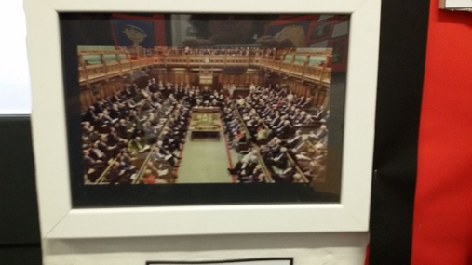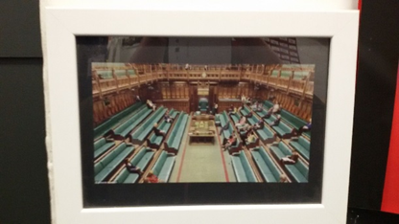  More information about the global goals: www.globalgoals.org
Modifications
Comments
Success    factors | This activity should be framed with the students, prior to the activity. This can be an introduction to »gender« in general.  Students go back from time to time to the posters. New ideas on gender-issues can be challenged by the posters. | Pitfalls  
The activity is flexible and depends on the local context. Feel free to adapt!
©
UDEL 21

