Field of diversity: | 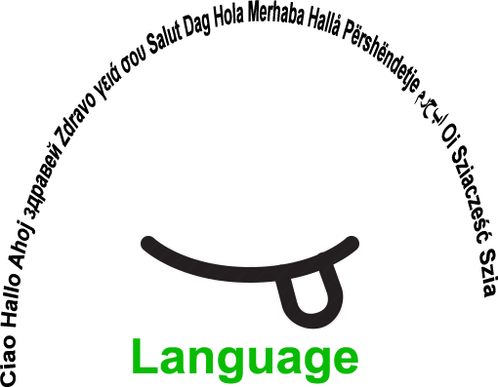 |  | BEfl |  | Group size:  
Title | Game: where is the key of the house?
Content | A game that enhances reading skills, verbal interaction and writing skills in different ways. source: Leen Pil, Prikkelbox (CEGO in samenwerking met provincie Limburt, LOP Genk, FLOB Aarschot Hasselt) |  |  |  |   Time: 20 minutes
Goals (Skills/Competences) | Pupils improve their reproductive and structured language skills: reading skills, verbal interaction, writing skills.
Material | - 2X a section of a house (one for each pupil)  - Set of 10 different pictures of house-items (one set for each pupil)  - Writing material
Procedure: | - Preparation, based on the knowledge of a popular game, e.g. “Sea Battle” (pupils may choose another one): visual instructions are offered and displayed: “he/she who locates the ships of the other player is the winner”  - Groups of 2: each pupil has a section of a house on the table with a barrier in between them (e.g. an open hard folder)  - Each pupil can place the set of 10 items in the rooms of the house (one item per room); this can be a not-so-obvious choice.  - Pupils take turns in guessing where the item is in the house of the other one by saying (example): in your house the key is in the kitchen. - The other pupil writes down the work “key” in the room that was chosen by the other (to remember which rooms he already guessed)  - The other pupil says “right” or “wrong” and when a pupil has guessed correctly he/she can put a circle around the item in the room or highlight it otherwise. If a pupil guessed wrong he/she can put a cross.  -The pupil that was first in guessing all the items is the winner.  @Leen Pil Prikkelbox https://www.klascement.be/cultuur/bib/56795
Modifications
Comments
Success    factors |  | Pitfalls  
The activity is flexible and depends on the local context. Feel free to adapt!
©
UDEL 21

