Field of diversity: | 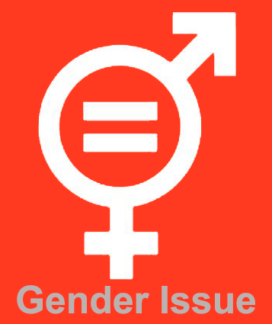 |  | BE |  | Group size:  
Title | Gender equality: facts in our world of today
Content | This is an awareness raising activity to draw students' attention on gender inequality in our world of today (global goal 5: www.globalgoals.org)  This activity is inspired by Netley Primary School, London. |  |  |  |   Time: 3 or 4 lessons
Goals (Skills/Competences) | Students are aware of gender issues in the world and where we are with our dreams for the future.
Material | Paper, glue, documents with data
Procedure: | - Teacher presents the fact files (age appropriate) about gender equality in different countries around the world, e.g. number of woman in political parties around the world. Teacher could choose to let the students collect the data. Students can choose the countries they want.  - Students order and compare the data to discover which countries are the closest to achieving the world we want.  - Students are put in groups of 4-5. The different groups make a flyer for each country, displaying the facts, e.g.: % of girls in education, % of woman in employment, % of woman in parliament, life expectancy for men and woman. Students can choose how to design the flyers (with picto’s, pictures, words, ….)  - The flyers are spread out in the school.  - Students express their thoughts in a designated space on the flyer.  - the flyers are fixed in the assembly-hall.  Link: www.globalgoals.org
Modifications
Comments
Success    factors | - Make the activity age-appropriate (if students can work with data and percentages, this can be used)  - Prepare by giving a lesson on 'the world we want to achieve'. | Pitfalls  
The activity is flexible and depends on the local context. Feel free to adapt!
©
UDEL 21

