Field of diversity: | 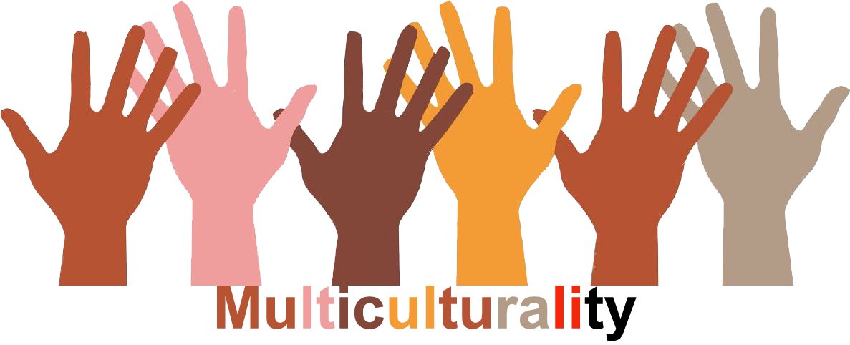 |  |  |  | Group size:  
Title | Learning more about refugees and migrants and their background.
Content | Students make posters with facts about the background of refugees and migrants. |  |  |  |   Time: 3-4 lessons
Goals (Skills/Competences) | Students learn about the situation and background of migrants and refugees and built on perspective-taking and empathy.
Material | Chart paper, internet, scissors, glue, newspaper and magazines, drawing material
Procedure: | - Students have a home-assignment (age-appropriate): they can look up information (e.g. political situation, history, other facts) and, if possible, conduct a structured interview in their neighbourhood (in this case, the teacher should have a lesson about this).  - Students prepare their poster (in groups or alone): they select a country, based on their home-assignment.  - Students can make the poster, using a design of their own choice: drawing, picto’s, documents from the internet, …..  - Students present the poster to each other. This can also be done with a drama-activity (the students act as the inhabitants of that country)  - The posters are fixed in the assembly hall or other mutual spaces, so they are visual for the whole school.  - From there on, other activities can be planned: cooking-activities, nature-sessions, ….
Modifications
Comments
Success    factors | - The class needs to go back from time to time to the posters and have a dialogue. They can invite other classes to this. | Pitfalls  
The activity is flexible and depends on the local context. Feel free to adapt!
©
UDEL 21

