Field of diversity: | 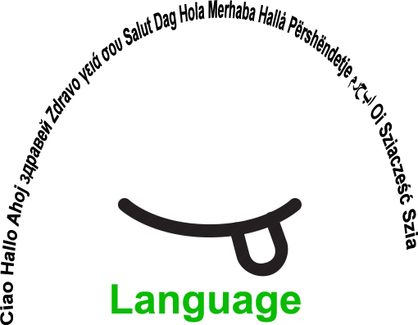 |  |  |  | Group size:  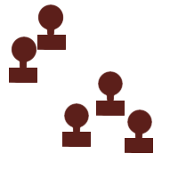
Title | Conversation islands.
Content | Children get to know each other through a language focused game. |  |  |  |   Time: 1 hour
Goals (Skills/Competences) | Students get to know each other through a language focused game (source: 'Playing CLIL' )  Students practice conversation and asking questions & giving answers.
Material | A4-sheets of paper with letters of the alphabet.  Different colored strings and scissors.  Different pictures, connected to the lessons (e.g. food, animal, nature...) in envelopes.
Procedure: | - The teacher prepares sheets of paper (A4) with all the letters of the alphabet and puts them in random order on the classroom floor with enough space between them to do the activity  - The teacher explains that every letter is an island. The space between them represents the sea so they can swim from one island to the other (in any way they choose). The students swim to an island with maximum 3 “inhabitants” per island.  - If a student finds him/herself alone on an island, he/she has to form a bridge to another island (by using a string).  - The teacher gives an envelope to each “inhabitant” of the island.  - The students make conversation, using the pictures in their envelope. The students decide themselves in which order the conversation happens.  - The teacher presents a conversation model and moderates if necessary.  Examples of questions: are there any birds on the island, do you have a volcano on your island, what fruit grows on your island?  Variation: students can prepare envelopes with their own choice of pictures.  Link: http://www.playingclil.eu/
Modifications
Comments
Success    factors |  | Pitfalls   |  | If there are non-native speakers in the class, the vocabulary should be adapted.
The activity is flexible and depends on the local context. Feel free to adapt!
©
UDEL 21

